**April Birthdays:**

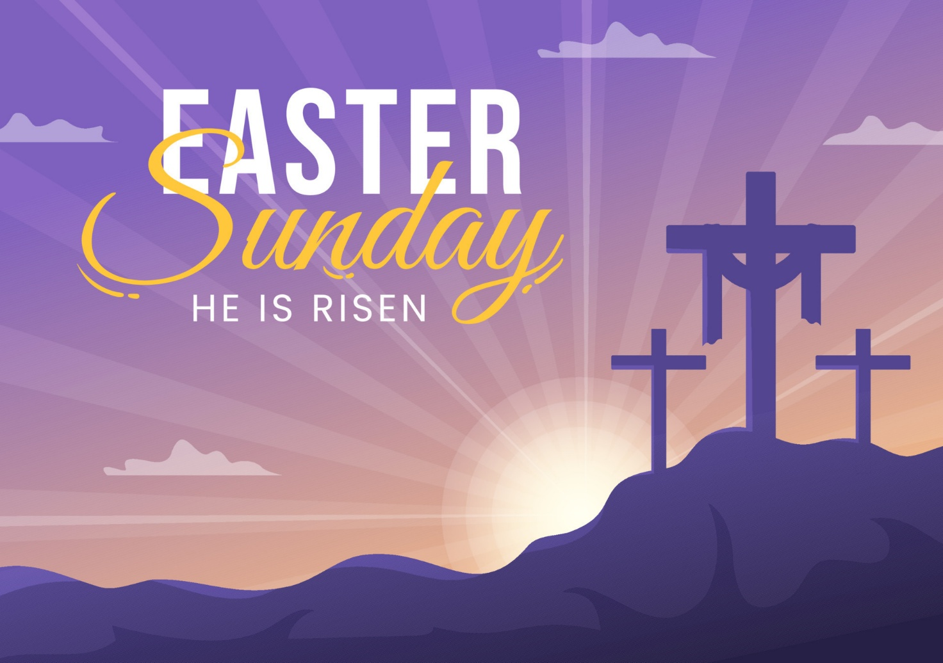

**Members**

Pail Robinson, Ellie Hunt, Jules Bliss, Sue Nicodemus, Florence LeRoy, Leah Wood, Vincent Battaglia Jr., Abbey Gragg, Maddie Gragg, Cindy Tavarez, Glenn Hansen

**Visitors**

Margaret McCloud, John Scotland, Steven Schneider, Isabelle Nazha, Tristan Somershoe, Julia Smith